Kearny County Hospital: Family Health Center & Surgical Services

Bowel Preparation Instructions for Colonoscopy
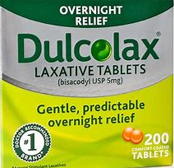

Items to purchase from the pharmacy/drugstore:
- One 8.2oz (238g) bottle or two 4.1 oz (119g) bottle of Miralax Laxative
(over the counter powder)
- 1 Box of Dulcolax Laxative tablets (Bisacodyl) DO NOT get the stool softener
- 1 Box of Simethicone (Gas-X) (over the counter) (125 mg Dose)
- 64oz of Gatorade, any flavor except those that dark red or dark purple

7 days before the procedure:_____/____/____
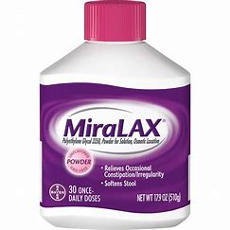
- Stop taking GLP1 injectable medications (weight loss/diabetic) and Rybelsus
  - Examples of injectables: Ozempic, Victoza, Mounjaro, Wegovy, Saxenda, Trulicity
- EKG will have to be completed before the procedure if 50 years old and over.
- A cardiac clearance may be deemed necessary before the procedure.

5 days before the procedure:____/____/____
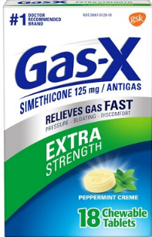
- Stop taking blood thinners: Aspirin, Plavix (Clopidogrel), Eliquis (Apixaban), Xarelto (Rivaroxaban), Pradaxa (Dabigatran). or Coumadin (Warfarin)
- Stop taking aspirin products: Ibuprofen, Aleve, Advil, Motrin, Naprosyn, or other arthritis medications
- Stop taking iron supplements
- Tylenol may be taken for pain as needed and as directed on the label.

2 days before the procedure:____/____/_____
- Starting at 5:00 p.m., begin a clear liquid diet.
- Clear liquids are any liquid that you can see through and have no solid substance.
- The following is a list of clear liquids ALLOWED:
Black Coffee | Tea | Soft Drinks | Grape Juice
Apple Juice | Gatorade | Popsicles | Jello
Beef Broth | Water | Hard Candy | Chicken Broth
- The following is a list of liquids/foods NOT ALLOWED:
Red or Purple Colored Liquids | Orange Juice | Milk or Dairy Products
Alcoholic Beverages | Tomato Juice | No Solid Foods

1 day before the procedure:
- At 12:00 p.m., Take 4 Dulcolax Laxative tablets. Taken them all together, without crushing or chewing.
- At 5:00 p.m., Begin drinking the Gatorade/Miralax mixture. Drink one 8oz glass every 10-15 minutes until solution is completely gone. Continue drinking clear liquids until bedtime.
- At 9:00 p.m., Take 2 Simethicone Gas-X tablets. These may be chewable depending on the brand.
Day of procedure:
- Do not eat or drink anything 6 hours before you scheduled procedure. This includes chewing gum or eating hard candy the morning of.
- Arrive at the hospital one hour prior to the time of your procedure unless you are instructed differently.
- A nurse from the surgical services will be contacting you by telephone for more detailed information.
- Enter Kearny County Hospital through the front entrance of the hospital. Check-in at the registration desk.
- You must be accompanied by an adult that can drive you home after the procedure.

